Iterative Workflows in LangGraph
The workflow generates a post and evaluates it. If the result is good, it is either used directly or sent for human approval. If it is not good, the post and evaluation are sent back to the LLM for improvement.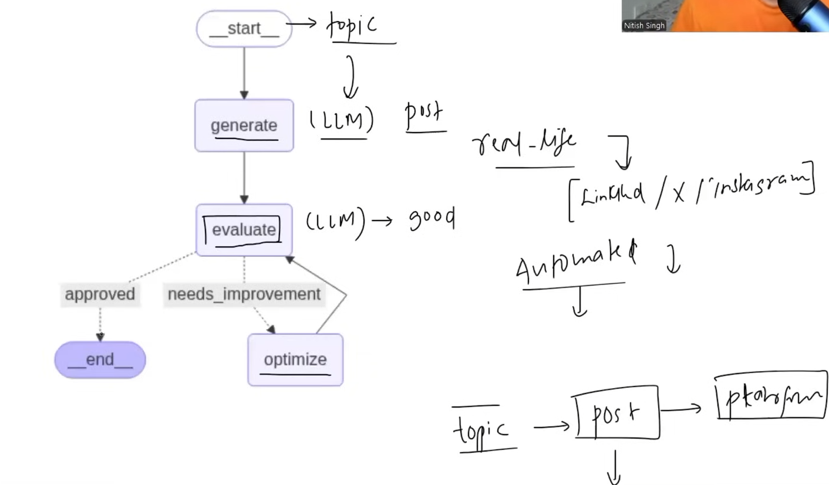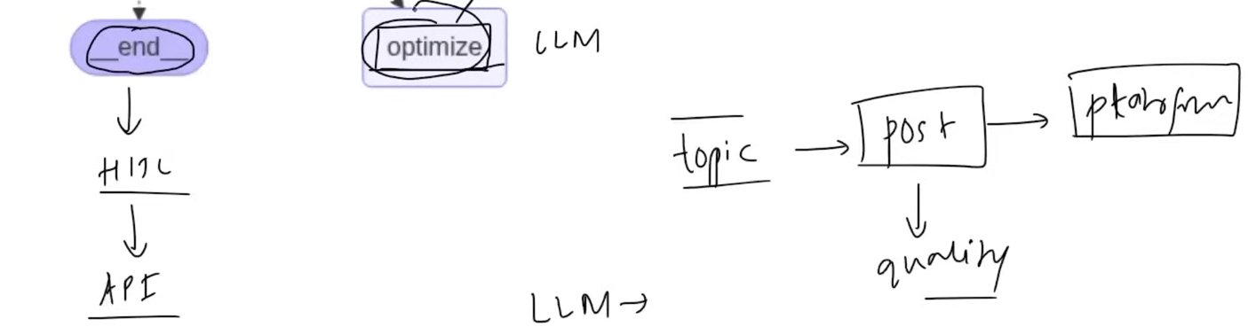

Ideally, we use different LLMs for different tasks, choosing models that are best suited for generation, evaluation, and optimization. However, in this example, we use the same LLM for all three tasks.
Code:- Here we created three LLM objects but we used the same model.
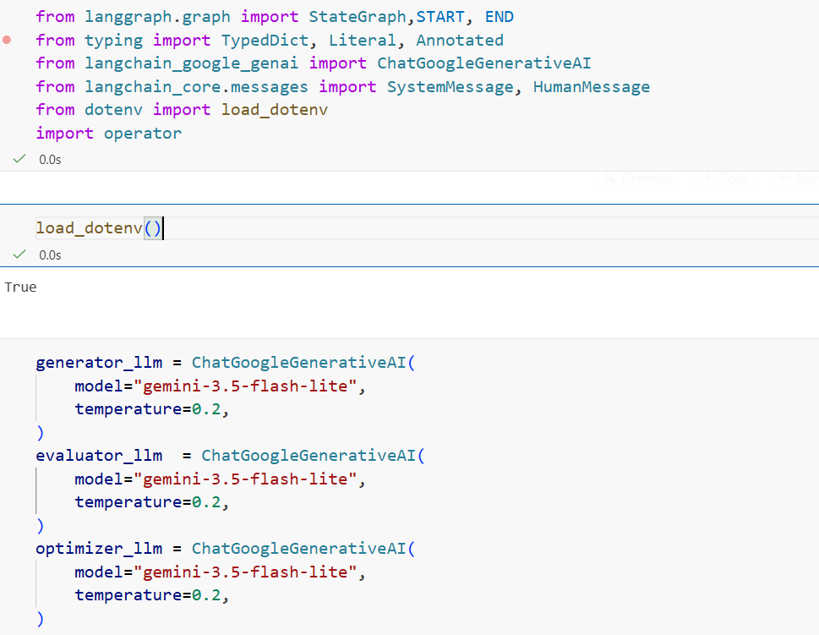
We create a schema that restricts the evaluator's response to only two possible outcomes: approved or needs_improvement. We then use this schema to create structured_evaluator_llm, which replaces the normal evaluator LLM.
tweet_history and feedback_history maintain the results from previous iterations. New tweets and feedback are added to the lists instead of replacing the previous values, allowing the workflow to track its progress. iteration keeps count of the iterations and, together with max_iteration, ensures the workflow does not exceed the allowed number of iterations.

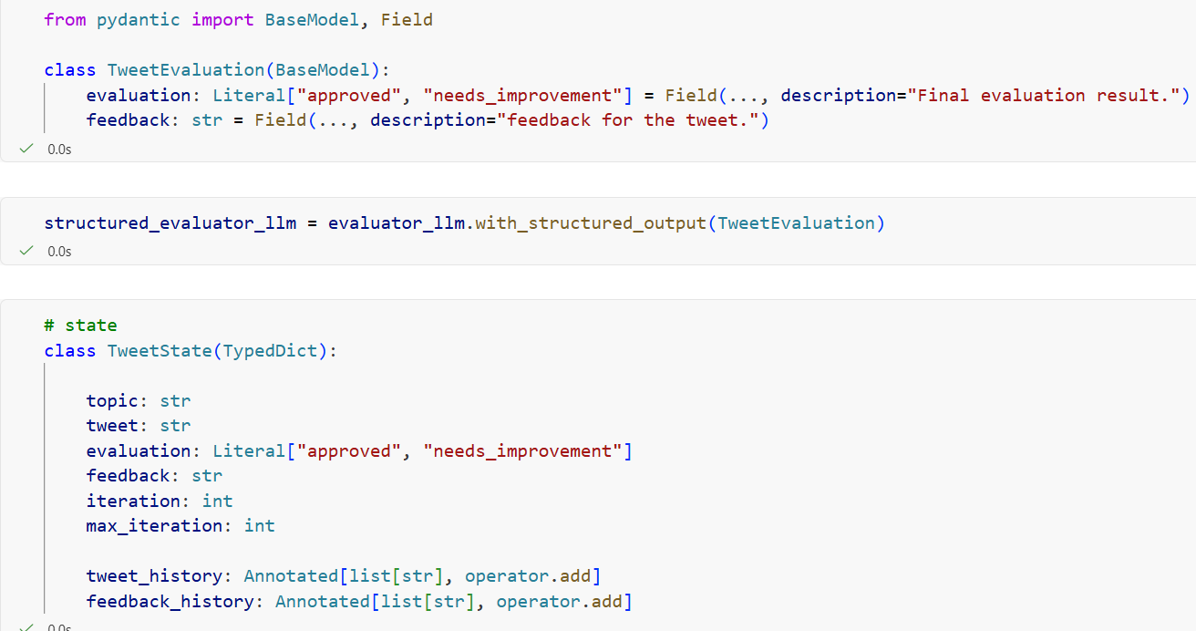
The node generates a new tweet and returns both the new tweet and the updated tweet_history. The new tweet is added to the existing tweet_history list rather than replacing it.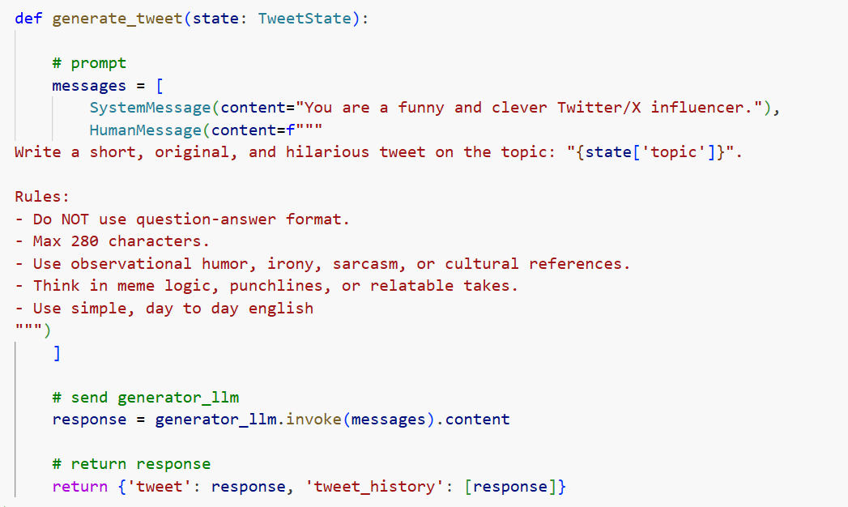

The node evaluates the tweet and returns the evaluation, feedback, and updated feedback_history. The new feedback is added to the existing feedback_history list rather than replacing previous feedback.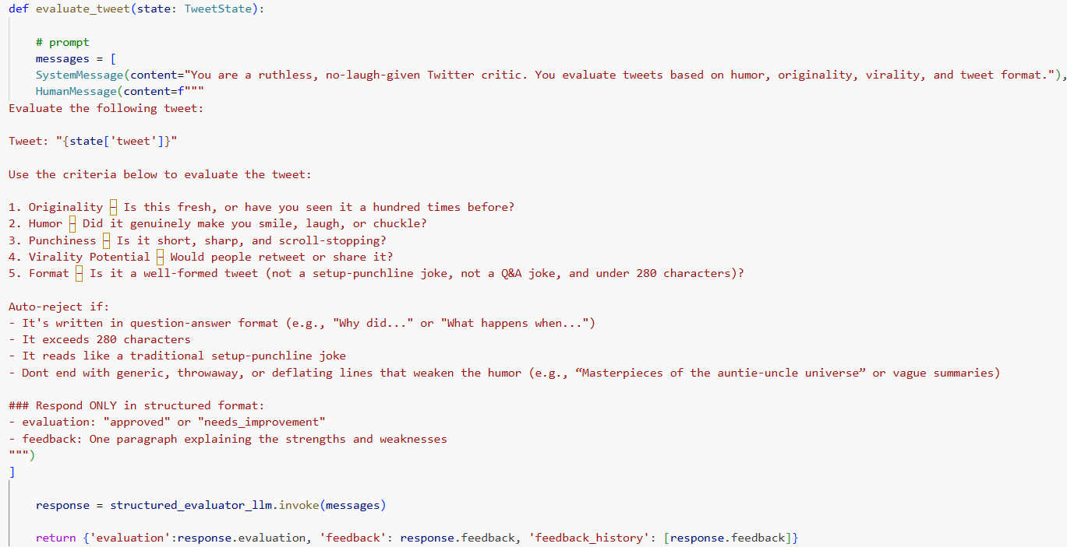

The node revises the tweet based on the feedback and returns the updated tweet. It also increments the iteration count by 1 and return it and adds the revised tweet to tweet_history.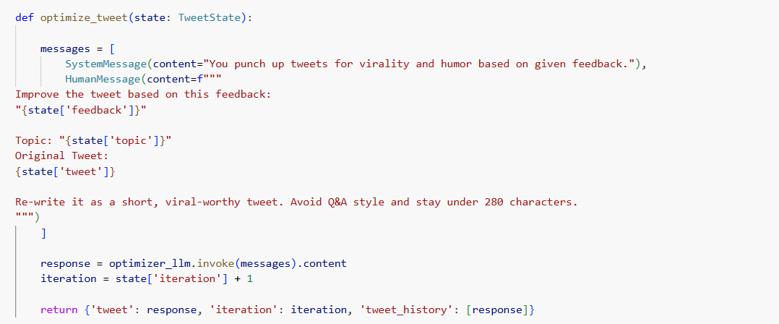
This function decides whether the tweet should be approved or improved. It checks both the evaluation result and whether the iteration count has reached max_iteration.
add_conditional_edges is used to decide which node to execute next based on the evaluation result. If the tweet is approved, the workflow goes to END; if it needs_improvement, it goes to optimize. Then, optimize is connected back to evaluate so the revised tweet can be evaluated again.